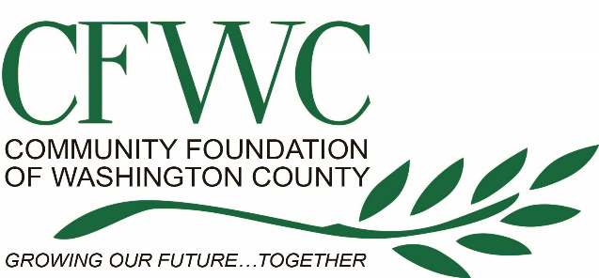

Community Foundation of Washington County
Business Sponsorship/Donation Form
Sponsorship/Donation Contact Name: | Email: Business Personal (please indicate)
Sponsor/Donor Address: Business Home (please indicate) | Sponsor/Donor Phone: Business Cell Home (please indicate)  Sponsor/Donor Fax:
Sponsor/Donor - Authorized Signature and Date: (Required)

Sponsorship Level or Donation Item/s
Presenting Sponsor $25,000+
Platinum Sponsor $10,000+

Delta Sponsor $7,500+
Gold Sponsor $5,000+

Silver Sponsor $2,500+

Bronze Sponsor $1,000+

Patron Sponsor $500+
Friend of Pathways $100+
In-Kind Donations/Description and Value:

___________________________________________________________________________________________
*Please make checks payable to:
Community Foundation of Washington County
P.O. Box 5910
Greenville, MS 38704
Office (662) 378-3141 Fax (662) 378-3143
Employer Identification Number: 46-1176207

